EL 2003 Comp Org & Assembly Language Lab

LABORATORY MANUAL ⦁Fall 2022⦁Instructor: Rukhsar ALI

|  |
| --- |
| **LAB 05** |

**Loop Instruction & Procedures**



|  |  |  |  |
| --- | --- | --- | --- |
|  | | | |
|  | | | |
|  | | | |
| Mohammad Yehya Hayati | | K21-3309 | G |
| ________________________________________ | | __________ | ___ |
| STUDENT NAME | | ROLL NO | SEC |
|  | | | |
| ______________________________________ | | | |
| SIGNATURE & DATE | | | |
| **MARKS AWARDED: ______________** | | | |
| ___________________________________________________________________ | | | |
| **NATIONAL UNIVERSITY OF COMPUTER AND EMERGING SCIENCES (NUCES), KARACHI** | | | |
|  | | | |
| Prepared by: | Rukhsar Ali |

**Lab Session 05: Loop Instruction & Procedures**

**Objectives:**

* Loop Instruction
* Built-in-Procedure

**Branching Instructions:**

Branching is the most direct method of modifying the instruction flow. A transfer of control, or branch, is a way of altering the order in which statements are executed. There are two basic types of transfers:

* Unconditional
* Conditional

**Unconditional Transfer:**

The unconditional jump instruction (jmp) unconditionally transfers control to the instruction located at the target address i.e. there is no need to satisfy any condition for the jump to take place. The general format is:

JMP *destination*

When the CPU executes an unconditional transfer, the offset of destination is moved into the instruction pointer, causing execution to continue at the new location.

**Syntax:**

Label:

……….

……….

……….

JMP *Label*

**Conditional Transfer:**

In these types of instructions, the processor must check for the particular condition. If it is true, then only the jump takes place else the normal flow in the execution of the statements is maintained. There are many instructions for conditional jumping, that we will explore in later labs. For this lab, our focus in only on LOOP instruction.

**Loop Instruction:**

The LOOP instruction, formally known as Loop According to ECX Counter, repeats a block of statements a specific number of times. ECX is automatically used as a counter and is decremented each time the loop repeats.

**Syntax:**

LOOP *destination*

The execution of the LOOP instruction involves two steps: First, it subtracts 1 from ECX. Next, it compares ECX to zero. If ECX is not equal to zero, a jump is taken to the label identified by destination. Otherwise, if ECX equals zero, no jump takes place, and control passes to the instruction following the loop.

**Syntax:**

MOV ECX, #COUNT

Label:

………..

………..

LOOP Label

**Example 01:**

INCLUDE Irvine32.inc

.code

main PROC

mov ax,0

mov ecx,5

L1:

Inc ax

call dumpregs

loop L1

exit

main ENDP

END main

**Example 02:**

INCLUDE Irvine32.inc

.data

intArray WORD 100h, 200h, 300h, 400h, 500h

.code

main PROC

mov esi, 0

mov eax, 0

mov ecx, LENGTHOF intArray

call dumpregs

L1:

mov ax, intArray[esi]

add esi, TYPE intArray

call dumpregs

loop L1

exit

main ENDP

END main

**Nested Loops**

When creating a loop inside another loop, special consideration must be given to the outer loop counter in ECX. You can save it in a variable.

**Syntax:**

MOV ECX, #COUNT1

LABEL1:

MOV VAR1, ECX

………..

*MOV ECX, #COUNT2*

*LABEL2:*

*MOV VAR2, ECX*

*………..*

*MOV ECX, VAR2*

*LOOP LABEL2*

………..

MOV ECX,VAR1

LOOP LABEL1

**Example 03:**

INCLUDE Irvine32.inc

.code

main PROC

mov eax, 0

mov ebx, 0

mov ecx, 5

L1:

inc eax

mov edx, ecx

call dumpregs

mov ecx, 10

L2:

inc ebx

call dumpregs

loop L2

mov ecx, edx

loop L1

call DumpRegs

exit

main ENDP

END main

**Procedure in Irvine32 Library:**

Some of the procedures available in Irvine32 library are:

1. **Clrscr:**

Clears the console window and locates the cursor at the above left corner.

1. **Crlf:**

Writes the end of line sequence to the console window.

1. **DumpRegs:**

Displays the EAX, EBX, ECX, EDX, ESI, EDI, ESP:EIP and EFLAG registers.

1. **DumpMem (ESI=Starting OFFSET, ECX=LengthOf, EBX=Type):**

Writes the block of memory to the console window in hexadecimal.

1. **WriteBin:**

Writes an unsigned 32-bit integer to the console window in ASCII binary format.

1. **WriteChar:**

Writes a single character to the console window.

1. **WriteDec:**

Writes an unsigned 32-bit integer to the console window in decimal format.

1. **WriteHex:**

Writes a 32-bit integer to the console window in hexadecimal format.

1. **WriteInt:**

Writes a signed 32-bit integer to the console window in decimal format.

1. **WriteString (EDX= OFFSET String):**

Write a null-terminated string to the console window.

1. **ReadChar:**

Waits for single character to be typed at the keyboard and returns that character.

1. **ReadDec:**

Reads an unsigned 32-bit integer from the keyboard.

1. **ReadHex:**

Reads a 32-bit hexadecimal integers from the keyboard, terminated by the enter key.

1. **ReadInt:**

Reads a signed 32-bit integer from the keyboard, terminated by the enter key.

1. **ReadString (EDX=OFFSET String, ECX=SIZEOF):**

Reads a string from the keyboard, terminated by the enter key.

1. **SetTextColor (Background= Upper AL, Foreground= Lower AL):**

Sets the foreground and background colors of all subsequent text output to the console.

1. **GetTextColor (Background= Upper AL, Foreground= Lower AL):**

Returns the active foreground and background text colors in the console window.

1. **MsgBox (EDX=OFFSET String, EBX= OFFSET Title):**

Displays a pop-up message box.

1. **MsgBoxAsk (EDX=OFFSET String, EBX= OFFSET Title):**

Displays a yes/no question in a pop-up message box.

1. **WaitMsg:**

Display a message and wait for the Enter key to be pressed.

1. **Delay:**

Pauses the program execution for a specified interval (in milliseconds).

1. **getDateTime:**

Gets the current date and time from system

1. **GetMaxXY (DX=col, AX=row):**

Gets the number of columns and rows in the console window buffer.

1. **Gotoxy (DH=row , DL=col):**

Locates the cursor at a specific row and column in the console window. By default X coordinate range is 0-79 and Y coordinate range is 0-24.

1. **Randomize:**

Seeds the random number generator with a unique value.

|  |  |  |  |  |  |  |  |
| --- | --- | --- | --- | --- | --- | --- | --- |
| Color and Its Value | | | | | | | |
| Color | Value | Color | Value | Color | Value | Color | Value |
| Black | 0 | Red | 4 | Gray | 8 | Light Red | C |
| Blue | 1 | Magneta | 5 | Light Blue | 9 | Light Magenta | D |
| Green | 2 | Brown | 6 | Light Green | A | Yellow | E |
| Cyan | 3 | Light Gray | 7 | Light Cyan | B | White | h |

**Example 04:**

**WriteDec:** The integer to be displayed is passed in EAX

**WriteString:** The offset of string to be written is passed in EDX

**WriteChar:** The character to be displayed is passed in AL

INCLUDE Irvine32.inc

.data

Dash BYTE " - ", 0

.code

main PROC

mov ecx, 1FFh

mov eax,1

mov edx, OFFSET Dash

L1:

call WriteDec ; EAX is writen as a decimal number

call WriteString ; EDX points to string

call WriteChar ; AL is the character

call Crlf

inc EAX ; next character

Loop L1

exit

main ENDP

END main

**Example 05:**

**DumpMem:** Pass offset of array in ESI, length of array in ECX & type in EBX

INCLUDE Irvine32.inc

.data

arrayD SDWORD 12345678h, 8A4B2000h, 3434h, 7AB9h

.code

main PROC

; Display an array using DumpMem.

mov esi, OFFSET arrayD ; starting OFFSET

mov ebx, TYPE arrayD ; doubleword = 4 bytes

mov ecx, LENGTHOF arrayD ; number of units in arrayD

call DumpMem ; display memory

call Crlf ; new line

call DumpRegs

exit

main ENDP

END main

**Example 06:**

**ReadInt:** Reads the signed integer into EAX

**WriteInt:** Signed integer to be written is passed in EAX

**WriteHex:** Hex value to be written is passed in EAX

**WriteBin:** Binary value to be written is passed in EAX

INCLUDE Irvine32.inc

.data

COUNT = 4

prompt BYTE "Enter a 32-bit signed integer: ", 0

.code

main PROC

; Ask the user to input a sequence of signed integers

mov ecx, COUNT

L1:

mov edx, OFFSET prompt

call WriteString

call ReadInt ; input integer into EAX

call Crlf ; new line

; Display the integer in decimal, hexadecimal, and binary

call WriteInt ; display in signed decimal

call Crlf

call WriteHex ; display in hexadecimal

call Crlf

call WriteBin ; display in binary

call Crlf

call Crlf

Loop L1 ; repeat the loop

exit

main ENDP

END main

**Example 07:**

**SetTextColor:** Background & foreground colors are passed to EAX

INCLUDE Irvine32.inc

.data

str1 BYTE "Sample string in color", 0

.code

main PROC

mov eax, yellow + (blue*16)

call SetTextColor

mov edx, OFFSET str1

call WriteString

call DumpRegs

exit

main ENDP

END main

**Example 08:**

**MsgBox:** Offset of content string is passed in EDX. Offset of caption is passed in EBX.

INCLUDE Irvine32.inc

.data

caption BYTE "Dialog Title", 0

HelloMsg BYTE "This is a pop-up message box.", 0ah

BYTE "Click OK to continue...", 0

.code

main PROC

mov ebx, 0 ; no caption

mov edx, OFFSET HelloMsg ; contents

call MsgBox

mov ebx, OFFSET caption ; caption

mov edx, OFFSET HelloMsg ; contents

call MsgBox

exit

main ENDP

END main

**Example 09:**

**MsgBoxAsk:** Offset of question string is passed in EDX. Offset of caption is passed in EBX.

Selected value is returned in EAX (If : YES equal to 6 OR If: NO equal to 7)

INCLUDE Irvine32.inc

.data

caption BYTE "Survey Completed",0

question BYTE "Thank you for completing the survey.", 0ah

BYTE "Would you like to receive the results?", 0

.code

main PROC

mov ebx, OFFSET caption

mov edx, OFFSET question

call MsgBoxAsk

;(check return value in EAX)

call DumpRegs

mov ebx, OFFSET caption

mov edx, OFFSET question

call MsgBoxAsk

;(check return value in EAX)

call DumpRegs

exit

main ENDP

END main

**Lab Task(s):**

1. Initialize an array named Source and use a loop with indexed addressing to copy a string represented as an array of bytes with a null terminator value in an array named as target.

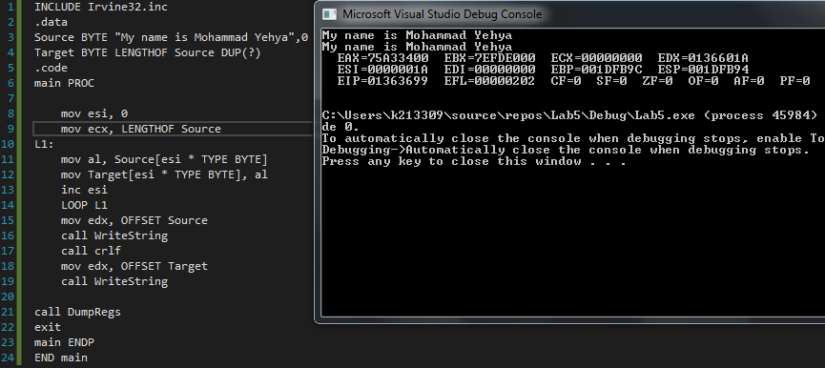

1. Use a loop with direct or indirect addressing to reverse the elements of an integer array in place. Do not copy elements to any other array. You can use SIZEOF, TYPE and LENGTHOF operators to make program flexible.

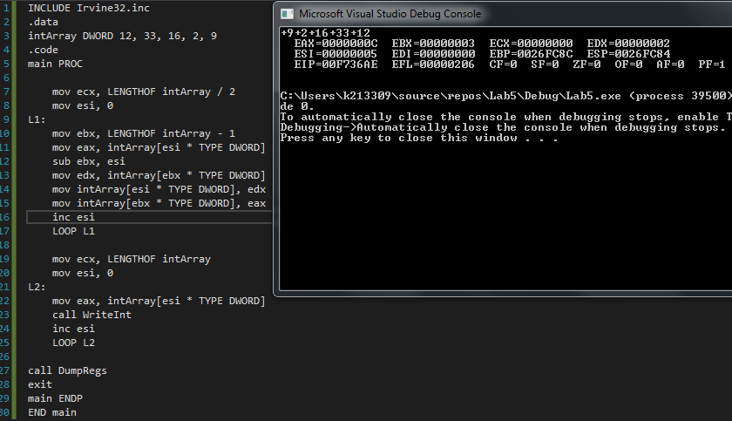

1. Write a program that uses a loop to calculate the first ten numbers of Fibonacci sequence.

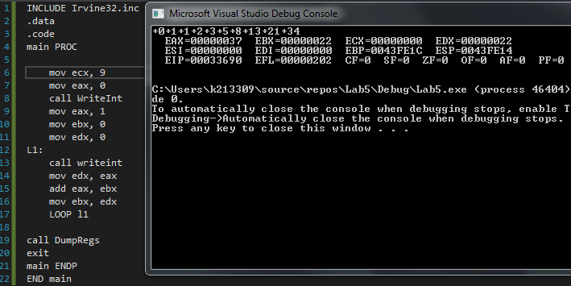

1. Write a nested Loop Program that give following output.



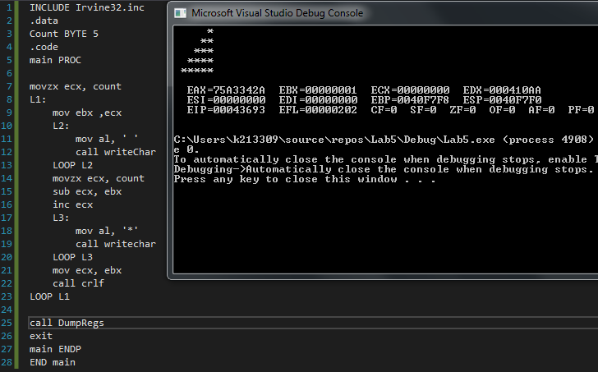

1. Write a program that enquire user about the quantity of Fibonacci sequence numbers to be display.

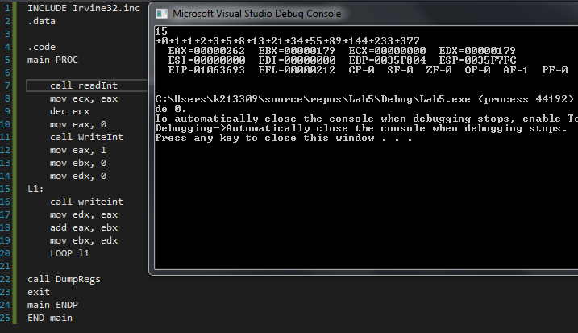

1. Implement task4 but user give input for number of lines for that triangle.

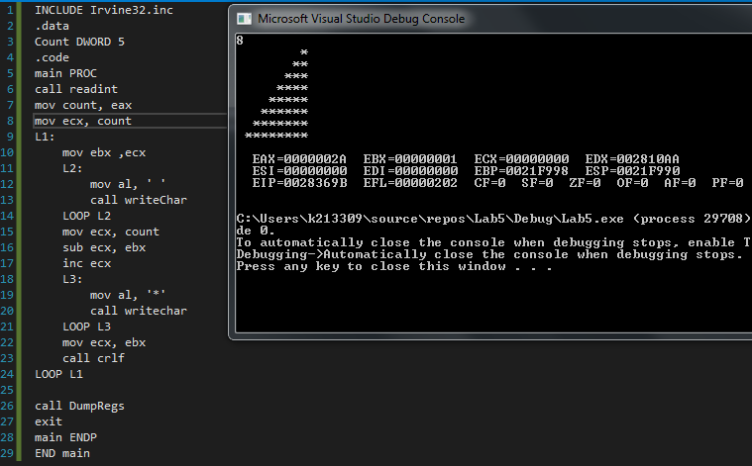

**Bonus Task:**

Write a program that uses a nested loop to implement following patterns (without using gotoxy procedure).

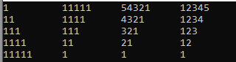

**Post Lab Task:**

You are required to practice the “WaitMsg, Delay, getDateTime, GetMaxXY, Gotoxy, Randomize, GetMSeconds” procedures.

Try to go through filehandling procedures.